ACE Pre-Conference AI Workshop Hands-on Activity

Background:
Large Language Models (LLMs) are advanced AI systems trained on extensive text data to understand and generate human-like language. LLMs have incredible capabilities across a broad range of tasks. However, many users are unaware that general-purpose LLMs can be adapted for technical or domain-specific use by customizing settings. By setting prompts and adjusting built-in parameters, such as temperature and max tokens, you can direct these models so that they can be effectively applied on technical tasks relevant to the water/environmental industry, such as interpreting water regulations or summarizing large engineering documents.
This guide introduces participants to these concepts through a hands-on activity. This exercise uses the Chat Playground in Microsoft Azure’s AI Foundry, a platform for experimenting with LLMs. The exercise will allow you to experiment with different settings to see how they influence LLM responses, explore the fundamentals of prompting, and learn how to ground LLM responses in relevant data.
Note: This guide contains information from the official Microsoft quickstart, Quickstart: Get answers in the chat playground (classic), adapted for today’s workshop.

Learning Objectives
- Familiarize participants with how to interact with Large Language Models
- Understand LLM Basics including how to formulate and refine prompts, improve the quality of responses from LLMs by grounding responses in task-specific data, and control outputs using parameters like temperature and max tokens
- Apply LLMs to a real-world task relevant to the water and environmental industries

Prerequisites and Setup
We configured a collaborative development environment in Microsoft Azure for workshop participants to use to complete this activity. All participants have access to this subscription for the duration of the workshop series.
Sign-In Instructions
- Go to the Azure portal: https://portal.azure.com
- Log In: Use the email and password associated with your Azure subscription.
- Download the Microsoft Authenticator Application on a smartphone and follow the on-screen instructions
  - Scan the QR code
  - Enter the one-time passcode
- Navigate to the Playground:
  - If needed, switch the organization to AI Client Workshops
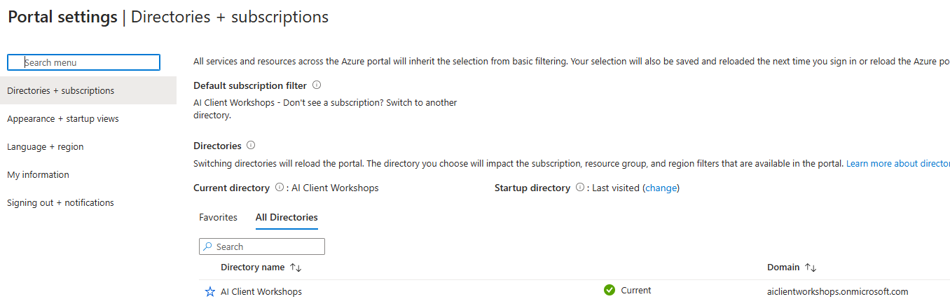
  - In the search bar, type “Azure AI Foundry” to find the existing resource (see below).

  - Then click on the button Playgrounds from the left-hand menu (see below).
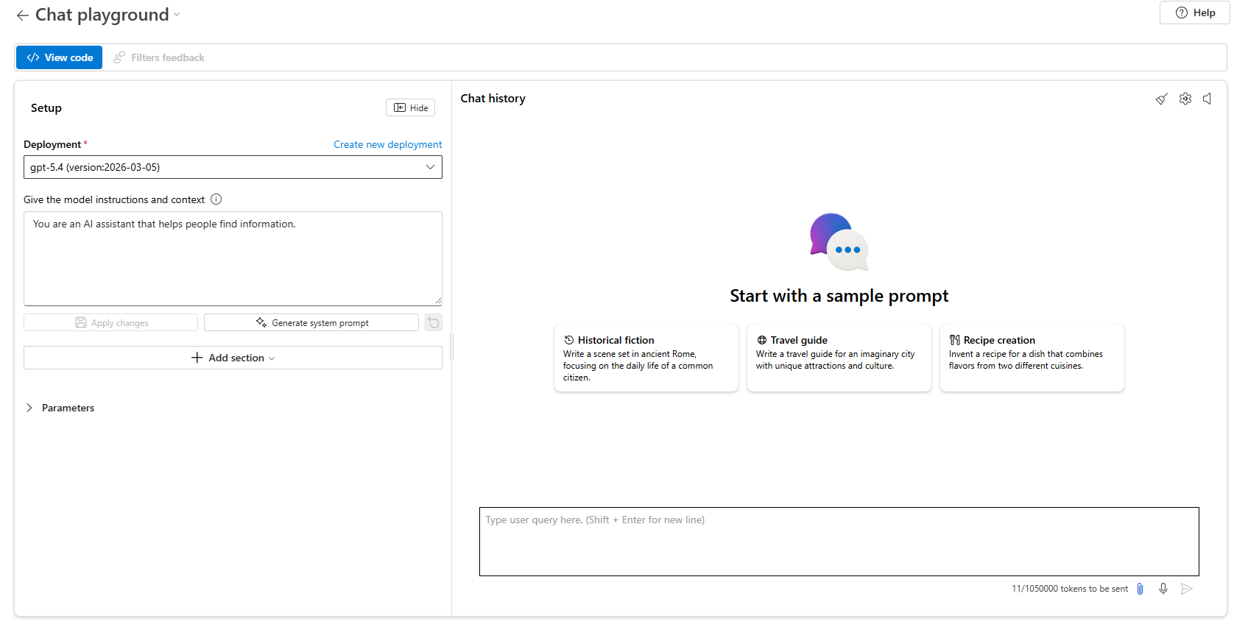

Activity Part 1: Using Chat Playground in Azure AI Foundry

Navigating the Chat Playground
The Chat Playground interface is divided into a left-hand side (configuration settings) and right-hand side (interaction with the LLM via chat). On the left-hand side, you can:
- Select a model (deployment) – you can choose from the list of available deployments (e.g., gpt-5.4). This determines which model is used for your chat session. A model was preset for you for this activity, but many alternative models are available in Azure AI Foundry.
- Enter a system prompt, in the playground called model instructions and context – Setting a system prompt guides the model on how to respond, often, with specific instructions on the output tone, length, and format. Example: “You are an AI assistant specialized in wastewater treatment regulations in Texas. Respond in short paragraphs that are understandable by a novice engineer.” In this exercise, we will use both the default settings and custom instructions.
- Add your data – Before the workshop, we prepared a dataset with information that will help the model generate high-quality responses questions posed here. We uploaded this data in advance so that during the activity, you can reference these documents in your queries and so that the model has access to this information when generating responses. As a part of this exercise, we will compare responses when the model is grounded in these documents vs. using only its built-in training data.
- View or modify settings such as temperature, max tokens, and other parameters.
  - Max Tokens: Limits how long the response can be.
  - Temperature: Adjusts creative vs. precise responses.
  - Other advanced parameters are also available but are not covered in this exercise. If desired, hover over the info icon to learn more about each setting.
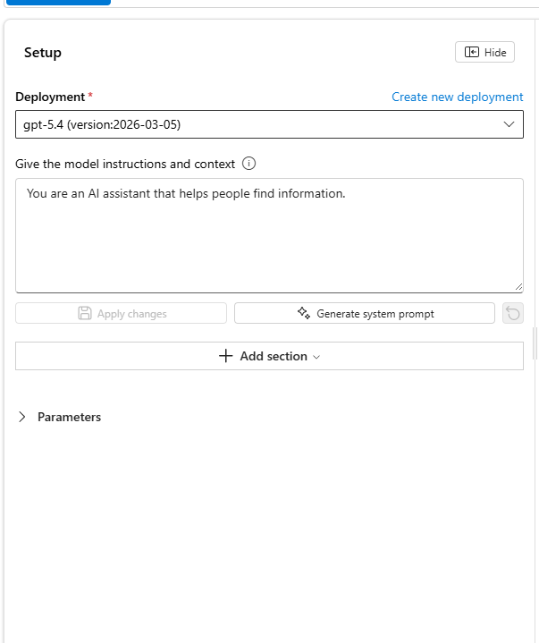
Figure 1 - Left-hand Panel - Configuration Settings
On the right-hand side, you can interact with the model using the input box:
- Input Box - Type your question or request in the input box. For instance, “Explain how Dallas manages water conservation, referencing the uploaded Dallas documents.” Click the Send button to generate the AI’s response in the right-hand panel.
- Clear Chat - You can clear the chat to reset the conversation context and begin again.
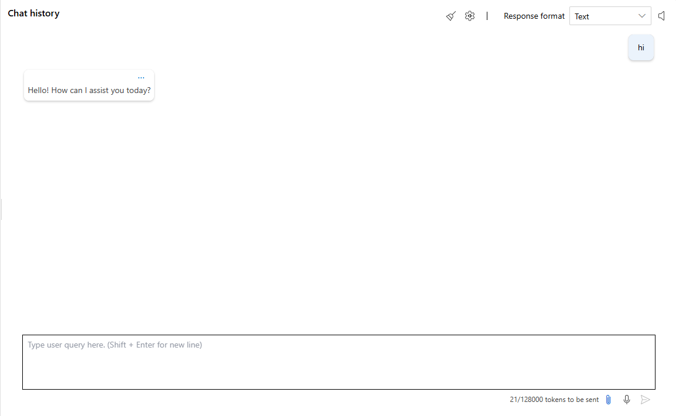
Conversation
Input Box
Send
Clear Chat
Figure 2 - Right-hand Panel - Interactive Chat
In this activity, we will learn about and explore each of these settings further.

Activity
- Start a Basic Conversation
Let’s start with a simple interaction with the LLM. You can select one of the sample prompts within the chat history box by clicking it, then, click the send button (bottom right) or press enter on your keyboard. Observe the LLM’s response.
Now, let’s interact with the LLM on a relevant topic. In the input box, type the following: “Can you tell me about innovative drinking water treatment technologies?” Then, click the send button (bottom right) or press enter on your keyboard.

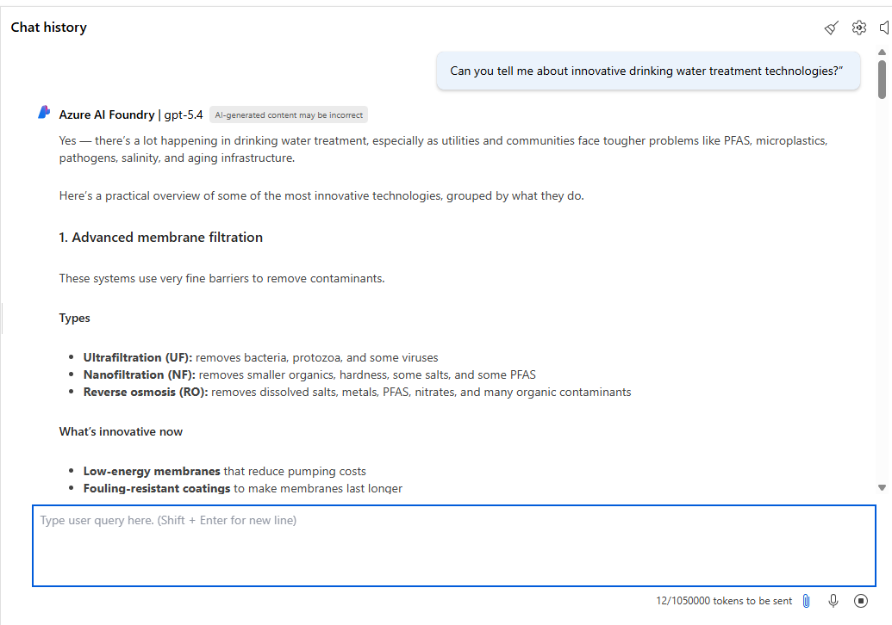
What’s happening?
Your question is transmitted to a cloud-hosted generative artificial intelligence model, which processes the information and generates a response.
Figure 3: Interact with the LLM by asking a general knowledge question
- Using the LLM to Generate an Educational Fact Sheet
Let’s imagine that you were using a LLM to help you develop an educational fact sheet for your customers about the importance of wastewater treatment and the treatment processes used at your organization’s facility.
  - To get started with this task, in the chat input (user input), type “How does drinking water treatment work?” then click send or press enter.

After, observe the response. Take note of the length and the type of information provided. An example response is below.
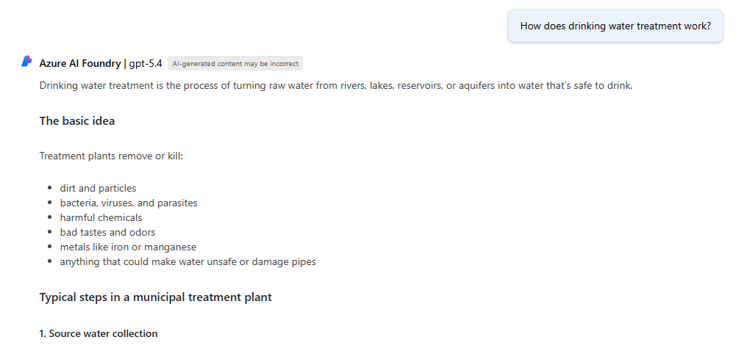
How does the model generate a response?
The model is trained on a large amount of data, which is used to understand language. The model interprets the input message, then creates a response by iteratively predicting what word to output next.
Figure 4: Water treatment question and response

Consider if the response was helpful or if you want to make it different when using this LLM to streamline your efforts on this task. Next, we will modify the prompt to see how we can guide the LLM to generate more helpful responses for this task.

  - Prompting for an Educational Fact Sheet: Adjusting the prompt
The above response may not necessarily be suitable for a public-facing factsheet. Let’s try getting the model to explain these concepts differently by updating the prompt, otherwise known as system message or instructions, that we provide the model to guide it in responses.

Update the model instructions (prompt) to the following:
“You are an AI assistant tasked with educating the public about drinking water treatment. Respond in a short paragraph using simple language at an 8th-grade reading level. Avoid technical jargon and use straightforward examples to clarify concepts.”
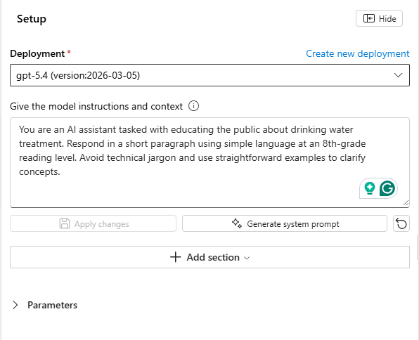
What model should I use?
Each model version is trained differently and has different performance, speed, and cost tradeoffs. Today, we will use a state-of-the-art model that performs well at general knowledge questions across a variety of topics. We can guide or instruct the model in how to generate responses by modifying the prompt.
Figure 5: Update the model instructions (prompt) to guide the model in generating responses
Click apply and, when prompted, click continue to start a new conversation.

Then, type in the input box: How does drinking water treatment work?

Observe: Did this new prompt influence the response? Was it more helpful for this task?
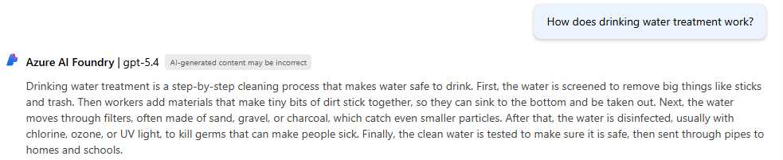
Figure 6: Example water treatment question and response with a refined prompt

Optional: Modify the prompt so that outputs are in the desired format (bullet points, short sentences, multiple paragraphs) and level of complexity (e.g. first grade reading level). Observe the variation in responses.
Explore More Prompts (Optional)
Optional: The Chat Playground has a Generate Prompt feature. You can copy and paste information about your task and a new detailed prompt will be created for you. Often, this prompt will contain information about output format, examples, and notes. What happens when you copy and paste the example above into the Generate Prompt feature, apply the changes, and ask a new question?
Optional: Instructions can be used to set the model persona. Can you make the responses funny or silly? What prompt do you think was used to create the response below?
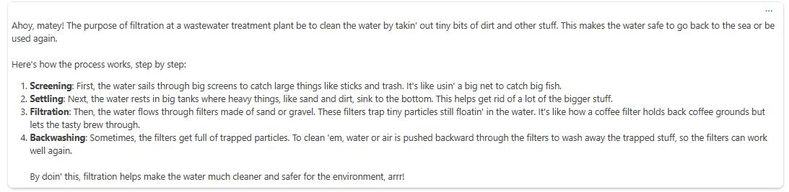

- Adjust Key Parameters
Earlier, you saw that we can adjust settings or parameters that influence how the LLM generates responses. Here, we will change two, temperature and max tokens.
  - Adjust Temperature
You can control the variability of responses with a parameter called temperature. Temperature can be assigned a value between 0-1, where low values have lower variability in responses. By default in the Chat Playground interface the value for this parameter is set at 0.7. Let’s see what happens when we adjust this value in the context of this topic.
Input the following in the text box: “What is the purpose of filtration at a wastewater treatment plant? How does this treatment process work?"
Observe the response.
Then, set the value for temperature to 1 and input the same question twice more. Are the responses identical or different each time?
Next, set the value for temperature to 0. Ask the same question again twice more and observe the response. An example is shown below.
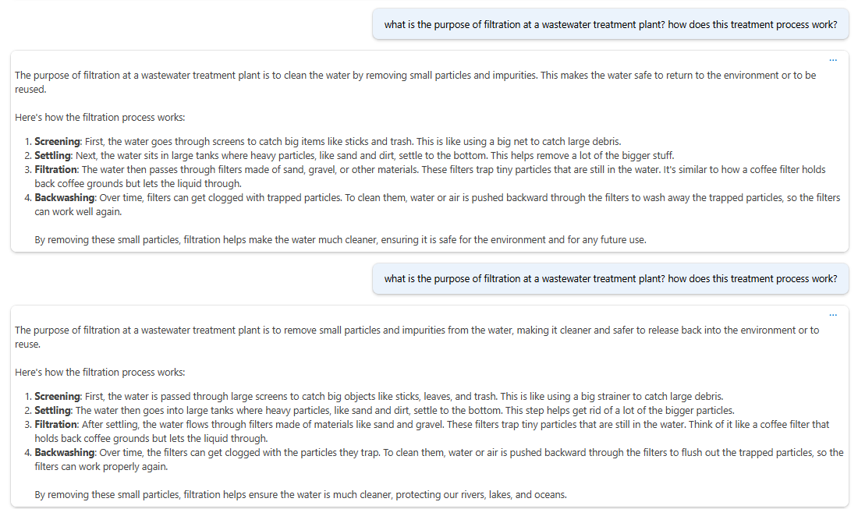
Figure 7: LLM responses were similar when the temperature was set to 0, and the same question was asked twice. While not shown here, the reverse was true when the temperature was set to a higher value like 0.7 (default) or 1.0 (maximum)
Were the responses when the temperature was set to 0 more alike compared to when the value was closer to 1?
Note: When configuring an LLM for a specific task, it is often helpful to set the temperature to 0 to reduce the variability in responses. This way, you can better observe how adjustments to other aspects of the configuration impact the LLM responses.
  - Adjusting Parameters: Max Tokens
Let’s next use the LLM to help us write a short description on the steps in a treatment process (e.g. coagulation and flocculation, sedimentation, filtration, disinfection, pH adjustment, etc.).
To do this, let’s further modify a LLM setting to ensure responses are succinct. Adjusting the prompt could help us with this and may be useful (e.g. respond in two sentences or less). We can also control this in a more rigid way by adjusting a parameter called max response (also referred to as max tokens). By default, this value is set to 800 tokens (about 600 words). A token is a part of a word (you can think of it like a syllable or ¾ of a word). Models generate responses token-by-token, which means the more tokens the model uses in its response the longer it takes to complete and the more costs are incurred. We can limit the number of token used in each response by adjusting the value for max tokens.
Adjust the value to be lower, like 300, then type in the input box explain coagulation and flocculation.
Let’s adjust the value again. What happens when you adjust the value lower to 100? Was the response cutoff? If so, that likely isn’t desired for this type of question and you may want to adjust it higher.
Before moving on to the next question, reset the value to 800 so responses are of sufficient length for most general inquiries in the rest of this exercise.
Optional: We know that there is a tradeoff between max response and cost. Can you think of a type of task where it would be helpful to set this to a low value? (Hint: automation or classification)
- Addressing Technical challenges of working with LLMs
We learned that LLMs are not perfect. LLMs are prone to two common forms of errors related to limited training data, which make it difficult for LLMs to answer questions factually about current events, and hallucinations.
  - Knowledge Cutoffs
Next, try asking a question about a current event.
Large language models generate responses based on their training data. The model used during the development of this activity was released in August 2024, but the knowledge cutoff for training data was October 2023, meaning that it does not have access to information after that date without relying on other tools (like web search).
Observe how the model responds to the example questions below: “Who won the super bowl in 2025?
Consider: Is the response you see factual? While the model may not provide an informed response, the answer is known, and so this response is not helpful.
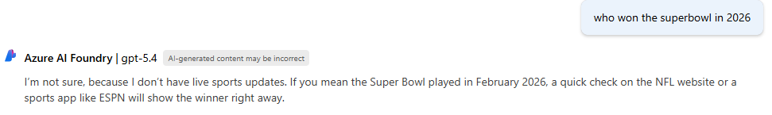
Figure 8: Current Event Questions and Responses
  - Hallucinations (part 1)
Next, we are going to ask questions related to your organization to see what the LLM knows about. Below are example questions.
Organization
Dallas | Fort Worth | Trinity River Water Authority
Tell me about water conservation efforts in Dallas. | What are some major water treatment challenges in Fort Worth? | How does Trinity River Water Authority manage regional water quality?

Please also ask follow-up questions or questions that you know the answer to based on your interests and your role at your organization so that you can evaluate the quality of the response:
Consider the responses. Is the LLM knowledgeable about your organization or was the response incorrect or vague, indicating that it was responding based on general knowledge of a topic rather than locally specific relevant details?
Was the response aligned with what you would expect or what you might write if you were talking with a friend? What changes would you make if you were revising this response to include in an email?
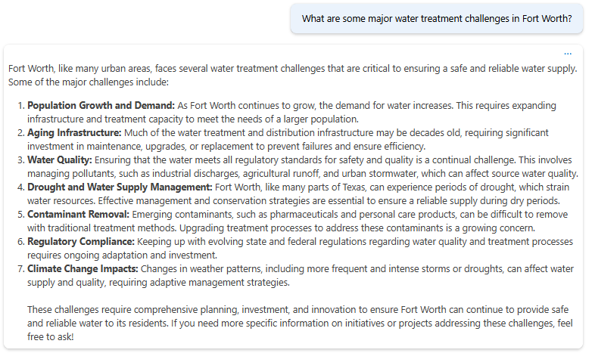
Is this correct?
The model was trained on many sources of data, including webpages, reports, and books. The response may be informed based on a compressed version of the information it was trained on; however, information may not be complete, up-to-date, relevant, or factual.
Figure 9: Example organizational-specific topic
  - Hallucinations (part 2)
In this final section, we will try to improve the LLM responses by providing it with access to data that it would not otherwise use when generating responses. This is beneficial for tasks that rely on data that is not in the training dataset (i.e. organizational-specific data).
Here, let’s create a short summary about capital improvement projects. Recall that earlier, we asked the model to “tell us about water conservation efforts in Fort Worth.” Without a specific prompt or data, the response was not specific. Try this again now that the data is connected to the LLM. Then, ask the LLM to provide citations and observe the response.
    - Compare LLM Responses with and without Data
Let’s see how the response changes when we provide the LLM with topic-specific information. Within “add your data” select the available project index (ai-workshops was pre-configured).
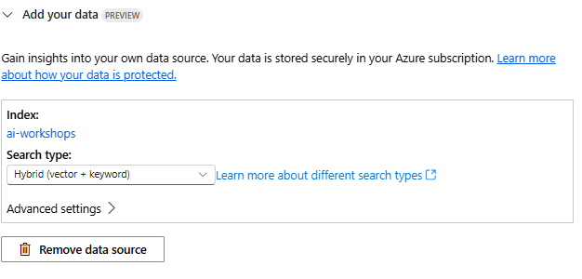
How is this data used?
This tool will subdivide a document into pieces and provide relevant portions to the LLM based on user input. The model will attempt to use the surfaced contextual information to develop responses that are grounded.
Update your prompt to guide the model to use the available data in the response. For example, add the sentence “Use the provided data to generate factual responses.” Click Apply.
Now, ask the same question, “Tell me about water conservation efforts in Fort Worth” again and compare the response to the prior one. Note the references at the bottom of the response. What else do you notice is different? Which response do you prefer and why?
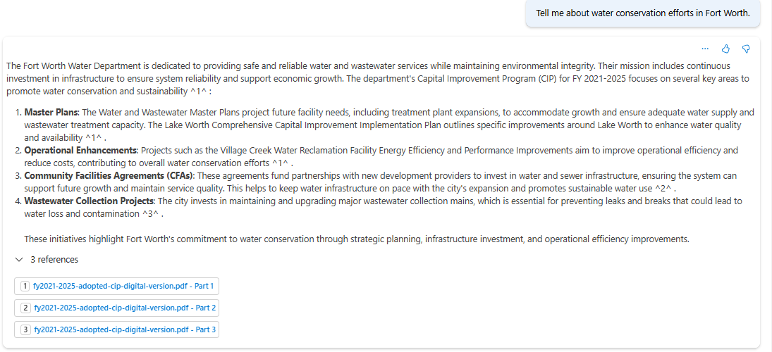
Figure 10 Example Response
Observe the response with citations. Click on one of the citations (expand the references section at the bottom of the response, if needed, then click a file, which will trigger a new panel to pop-up on the right of the chat interface). Review the information and verify that the response is grounded in the information from the source document, a Capital Improvement Plan from Fort Worth.
- Creating Structured Responses
So far, the LLM has generated unstructured text responses. Let’s see if we can guide the LLM to generate a more structured response, like a table with information that we care about, so that we can more easily incorporate it into a spreadsheet or a summary report.
Modify the prompt to:
You are an AI assistant that helps people find information. You generate tables with the following headers: capital improvement program name, description, cost, and year implemented. Always display information in this output format.
Now, input into the text box:
Provide a list of planned and recently completed water capital improvement projects in Fort Worth.
Observe the response format and contents. Was the table fully populated with the desired data? Was the information accurate? Was it complete? A sample response displaying the entire configuration is below, for your reference.
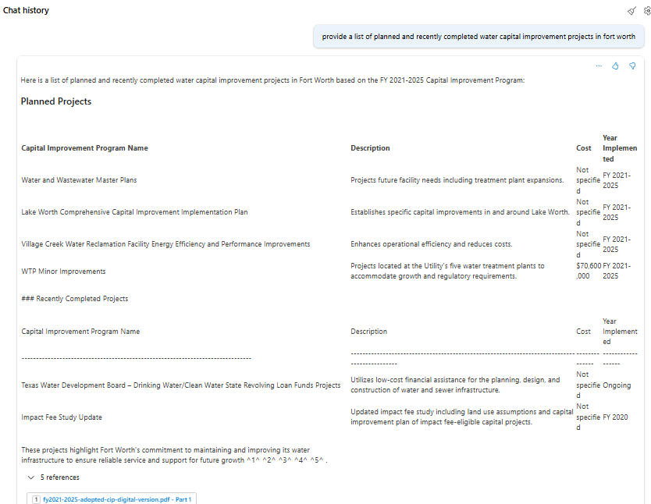
The response was informed by the provided data and generated a citation accordingly
This system identified relevant contextual information in the uploaded document to answer the question and used that data to create a summary table.
Figure 11 Structured responses
Note on completeness: Providing the LLM with data does not guarantee that information provided in the response will be complete. It may be necessary to use other techniques besides chatting over data when trying to generate complete responses, especially when information needed to create a response is contained across multiple pages or documents.
Note on validating the output format: Additionally, notice that while this prompt says to format information as a table, it still contained a sentence before and after the table. It is possible to refine the prompt and validate that the output is in the desired format. Though that is often beneficial when automating tasks, it is beyond the scope of this exercise.

Working with your own data (Optional)
It’s possible to use this interface to add your own data so that you can modify what kinds of questions the LLM is able to respond to. If you upload data, ensure it does not contain sensitive information and follow your organization’s data privacy policies. This is not necessary for this exercise, but if it is desired for a future exercise or post-workshop assignment, please contact us and we can assist you with this process.

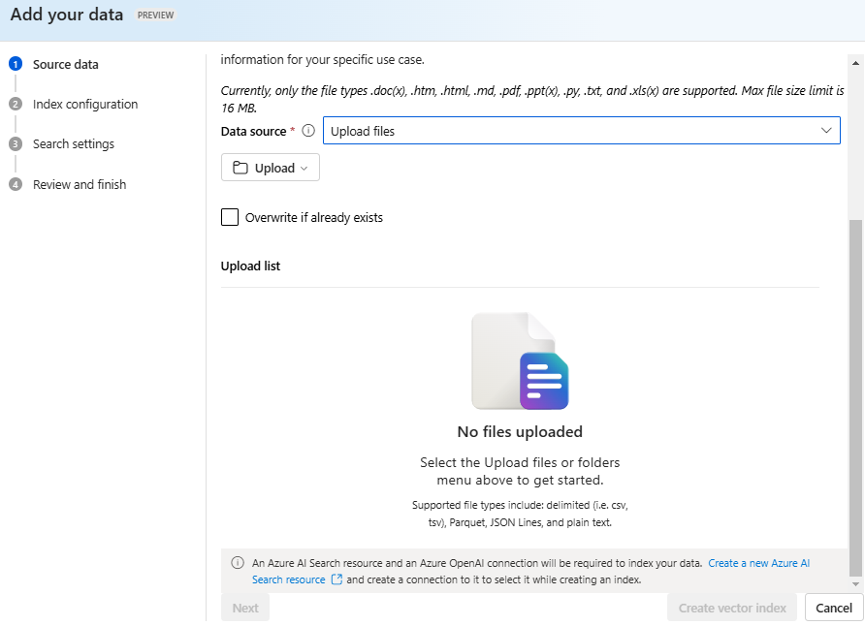
Figure 12 Interface for uploading data so that it can be accessed by an LLM
- Safety and Guardrails
LLMs are trained on a variety of topics which allows them to be used across many different types of tasks. However, when we develop tools for specific purposes, we do not necessarily want LLMs to respond to questions that are off topic or that could enable inappropriate uses. There are multiple ways to manage responses from an LLM. Here we will demonstrate safety system messages.
  - Add a system safety message by adding a section within the left-hand panel, as shown below. For this exercise, click ‘select all’ and ‘insert’.
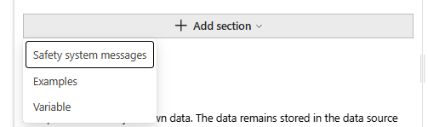

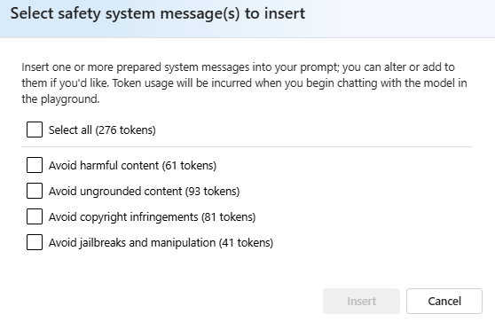
  - Next, add an additional safety message that guardrails what kinds of questions the LLM responds to. For example,
## To guardrail topic scope
- Only to user messages related to water

Validate this by asking an off-topic question. An example is below:
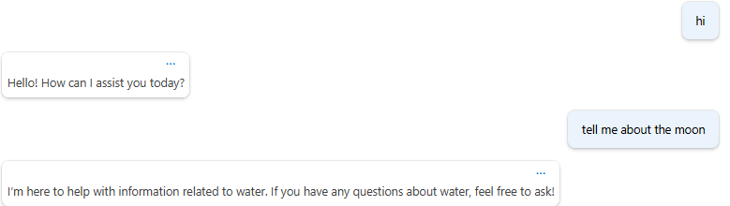
Figure 13 The LLM Safety Message prevented the LLM from responding to an off-topic message
Consider what types of tools might require a guardrail like this.
(Hint: Remember that there are AI regulations on the operation of critical infrastructure, and there may be additional guardrails needed when providing public facing tools like those related to customer service)

Key Take-aways and Tips
In this activity, we learned that that there are many ways to guide LLMs to modify the types of responses they generate (e.g. length, style/tone, variability, groundedness). Learning how to guide general-purpose models helps us to apply LLMs on specific tasks relevant to the water and environmental fields in an effective and responsible way.
LLM Knowledge Limits: The model only knows what was in its training data, plus what you provide. Responses may be convincing but LLM responses may not be factual or complete.
Importance of Grounding: Providing curated and factual documents ensures more relevant, up-to-date answers. Follow your organization’s data governance rules if you are providing private or sensitive information to an LLM.
Prompt Tip: Specifically mention “Use the documents…” to instruct the model to reference them when generating a response and instruct the model to include references if you need to confirm accuracy.
Iterate & Refine: Prompt engineering is iterative. Slight wording changes can lead to significantly better results.
Key Settings:
Setting | What It Does | When to Use
System Instructions | Controls outputs (including style/tone, length and format of outputs) | When trying to guide the LLM to produce a response that aligns with your needs
Data | Provides the model with relevant information to respond to a user | When using LLMs of a task requiring specific or private knowledge
User inputs | Provides a request or question to an LLM | Required for each interaction

Key Parameters:
Parameter | What It Does | Typical Values | When to Use
Temperature | Controls randomness and creativity of responses | 0–1 (default at 0.7) | Brainstorming (0.7 or 1) vs. factual tasks (near 0)
Max Tokens | Caps response length (affects cost & speed) | 100–4000+ | Set low when you need concise outputs or high when you want longer responses

Activity Part 2: Using AI for no-code tool development @yoko and @craig

Risk, privacy, and governance

Wrap up and Next Steps
You have now configured a LLM that can answer technical questions on a specific topic grounded in relevant data. You learned how to guide it to generate responses in a way that was meaningful for the task and applied guardrails to mitigate potential misuse by users. You can now interact with this LLM as a chatbot tool!
For your post-workshop assignment, consider how an LLM application might be used by others in your organization or by you in your role. For example, you might want to be able to create a tool that allows users upload their own data on a topic and ask questions about it. Additionally, as you’ve learned LLMs can be used for more than just chatbots – for example, for automating data entry with a consistent set of inputs. Given what you know about LLM capabilities, consider what applications might be useful, and determine the data needed to ensure it produces high quality responses.

Resources and References
Official Microsoft Documentation
  - Get started with Azure AI Studio: Quickstart Guide
  - Azure OpenAI overview
  - Responsible use…

